1. EXPLORE MORE ABOUT NEURAL NETWORKS AND DEEP LEARNING MODELS.

* Neural networks are computational models that mimic the complex function of the brain.It consists of interconnected nodes or neurons , connections, weights, bias and a learning rule.It is composed of an input layer, an output layer and one or more hidden layer.

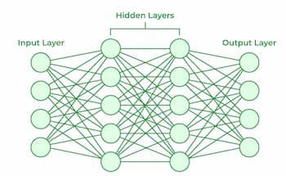

* Working of a neural network:

*Forward Propagation*:

**Input layer**: Each feature in the input layer is represented by a node on the network, which receives input data.

**Hidden layer**: Each hidden layer neuron processes inputs by multiplying

the by weights, adding them up, and then passing them through an activation

function. By doing this, non-linearity is introduced, enabling the network to

recognize intricate patterns.

**Output**: The final result is produced by repeating the process until the output

layer is reached.

Backward Propagation:

**Loss calculation:** This function is used to evaluate the model’s

performance. For regression problems, MSE is used commonly.

**Gradient descent**: It is useful to optimise the loss function for better

performance of the model.

**Activation function:** Activation function is determine whether a neuron

should be fired or not. There are many activation function like ReLU, Sigmoid

function, Tanh function.

* ***Deep learning models:***
* **Convolutional Neural Network (cNNs):** Convolutional neural network is an algorithm to do image classification and image recognition in neural networks.CNN’s have multiple layers that process and extract features.
* Convolution Layer: It is a mathematical operation which takes two inputs such as image matrix and a kernel.Convolution of an image with different filters can perform an operation such as blur, sharpen, and edge detection by applying filters.
* Pooling Layer: Pooling is a down-sampling operation that reduces the dimensions of the feature map.The pooling layer then converts the resulting two-dimensional arrays from the pooled feature map into a single, long, continuous, linear vector by flattening it.
* Fully Connected Layer: A fully connected layer forms when the flattened matrix from the pooling layer is fed as an input, which classifies and identifies the images.
* **Long Short Term Memory Networks (LSTMs):** LSTMs are a type of Recurrent Neural Network (RNN) that can learn and memorise long-term dependencies.When we try to predict the next letter of any sentence, then LSTMs play an important role.It works like
* First they forget irrelevant parts of the previous state.
* Next, they selectively update the cell-state values.
* Finally, the output of certain parts of the cell state.
* **Recurrent Neural Networks (RNNs):** RNNS is a type of neural network where the output from the previous step is fed to the current step.The main and most important feature of RNN is its Hidden state, which remembers some information about the step.It works like
* The output at time t-1 feeds into the input at time t.
* Similarly, the output at time t feeds into the input at time t+1.
* RNNs can process inputs of any length.
* **Generative Adversarial Networks (GANs):** A generative adversarial network is a neural network that is made up of two neural networks - a discriminator and a generator.The discriminator separates generated data from real data, while the generator produces synthetic data that attempts to imitate real data.

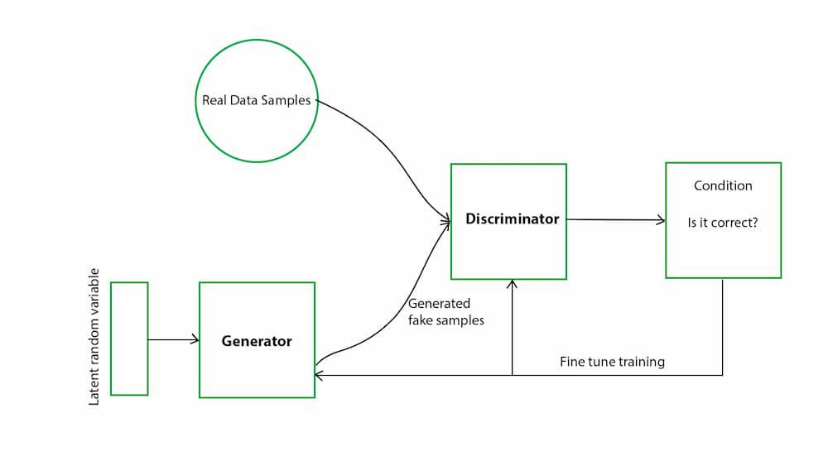

* **Multilayer Perceptrons (MLPs):** MLPs consist of an input layer, an output layer and one or more hidden layers.
* Input layer takes data as input.
* MLPs compute the input with the weights that exist between the input layer and the hidden layers.
* MLPs use activation functions to determine which nodes to fire. Activation functions include ReLUs, sigmoid functions, and tanh.
* Finally it gives predictions through the output layer.
* **Autoencoders:** Autoencoders are deep learning algorithms that are designed to receive an input and transform it into a different representation.We can use them to compress the data and reduce its dimensionality.Autoencoder consists of three layers:
* Encoder:The Encoder layer compresses the input image into a latent space representation. It encodes the input image as a compressed representation in a reduced dimension.
* Code: The Code layer represents the compressed input fed to the decoder layer.
* Decoder: The decoder layer decodes the encoded image back to the original dimension. The decoded image is reconstructed from latent space representation.

